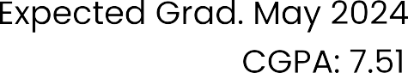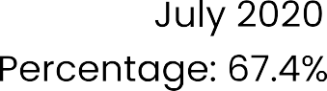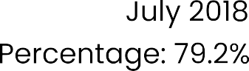

[](https://www.linkedin.com/in/vansham-patel-067181279)[](https://github.com/vanshampatel)









[](https://vanshampatel.github.io/change-course/)

